**Title in English**

**subtitle in English (if exists, otherwise delete)**

MasterThesis

Study program: Biomedical and Clinical Engineering

Supervisor of the master thesis: (name including degrees)

**Name Surname** (master thesis author, including degrees)

First page of the thesis. Replace the text in red by specific data in black colour or adjust according to your needs. Remove commentaries highlighted in yellow and green. Instructions in yellow are binding for the theses submitted at the Department of Biomedical Technology, green ones are recommendations only. Read the instructions in the whole template including attachments.

**Thesis Assignment**

Instead of this page, insert the diploma thesis assignment, which you will confirm and download from **KOS system in PDF format** after receiving a request (an email from **noreply@cvut.cz** with the subject "**Invitation to accept assignment**" will be sent to the student). **Without the inserted signed assignment and declaration, the thesis may not be accepted for defense!** Instructions can be found on the FBMI website under the STUDENT tab, subsection Bachelor’s and Master’s Theses. The assignment includes a validity period—only valid thesis assignments are relevant. When evaluating the thesis, the extent to which the assignment has been fulfilled is assessed. Ensure the readability of the assignment—do not insert compressed versions or screenshots of the assignment!

The declaration is a mandatory part of the thesis. Instead of this page, insert the "**Declaration of Originality and the Use of AI**", which you will confirm and download from KOS system in PDF format. Instructions can be found on the FBMI website under the STUDENT tab, subsection Bachelor’s and Master’s Theses. **Any thesis without the signed declaration may not be accepted for the defense.**

Obsah obrázku text, snímek obrazovky, software, Webová stránka

Obsah vygenerovaný umělou inteligencí může být nesprávný.

**ACKNOWLEDGEMENTS**

I would like to thank ………….

Acknowledgement is optional, but common. You should thank your supervisor. You should never thank to your reviewer. Acknowledgments may also be extended to consultants, professional workplaces, institutions, their management, and other entities, usually for enabling the realization of the practical part of the thesis. When thanking an individual, include all academic titles, full first and last name. When acknowledging an institution, use its full official name, not an abbreviation. Discuss with the supervisor whether a grant number by which the thesis has been supported (if any) should be mentioned here.

Clearly state the main aim of the thesis in the abstract (e.g. „The aim of the thesis was to devise a device which will enable…“).

**ABSTRACT**

**The title of the Thesis:**

The abstract is written in paragraphs and follows the structure of the thesis. It should provide a concise summary of the work itself, including its content and focus. The abstract must explicitly state the main objective of the thesis (e.g., "The aim of this thesis was to design a device that enables…"). It is essential to include information about the achieved results and their description. The abstract should use professional terminology and be concise, factual, precise, informative, and engaging. The length should not exceed one standard page—1,800 to 2,000 characters.

**Keywords**

A list of 5 to 7 words or phrases separated by semicolons, representing the topic of the thesis and the methods used, arranged in order of relevance from the most important.

The minimum number of characters for keywords is 20 in Czech and 30 in English, while the maximum number of characters for both languages is 1,000.

Table of Contents

List of symbols and abbreviations 7

1 Introduction 8

2 Overview of the current state of the art 9

3 Aims 10

4 Methods 11

5 Results 12

6 Discussion 14

7 Conclusion 15

References 16

Attachment A: Formatting requirements 17

Attachment B: Basic typographic rules 18

Attachment C: Further recommendations for the sake of clarity of the text 19

The content of the thesis can be created automatically, if Heading 1, Heading 2 etc. are used as headings. Use maximum 3 levels of subchapters.

# List of symbols and abbreviations

List of abbreviations and symbols used in the thesis is obligatory for theses defended at the Department of Biomedical Technology. It is placed between the Table of Contents and the text of the thesis as such. Please have a separate table for symbols and a separate table for abbreviations.

A list of figures and tables can be placed after the list of abbreviations. These lists should be included only if there are many figures and tables in the thesis.

#### List of symbols

|  |  |  |
| --- | --- | --- |
| Symbol | Unit | Importance |
| *CDP*end | cmH2O | Continuous distending pressure after stabilisation of the transient action |
| *f*HFO | Hz | Frequency of high frequency oscillations |
| *N* | 1/s | Parameter of low-pass filter connected to PID controller |

#### List of abbreviations

|  |  |
| --- | --- |
| Abbreviation | Importance |
| ALI | Acute Lung Injury |
| PID | Proportional-integral-derivative |

# Introduction

The beginning of the introduction contains a brief general introduction into the given topic (defines the field of the thesis, states the motivation etc.). The general introduction should only constitute a very small part of the thesis.

# Overview of the current state of the art

The overview of the state of the art of the issue being dealt with summarises in detail (1) current state of the art and initial conditions for a solution not only in the Czech Republic but also abroad (2) defines a problem which needs to be solved and will be solved in the thesis. This part of the thesis is mainly a bibliographic research using many sources. Start with the most general information, proceed to the more detailed, and state what is known about the given issue and what needs to be solved. Such an explanation will logically result in the below specified aims.

# Aims

The aims of your work, based on the assignment of the thesis, should be accurately described here, not copy of the bachelor’s thesis assignment text form the PROJECTS system. In contrast to the very brief assignment of the work, it is necessary to specify the aims in more detail here and it is appropriate to expand the aims into specific sub aims.

# Methods

This chapter contains a detailed description of how the student solved the problem. Depending on the nature of the problem being solved, this part of the thesis can be divided into several chapters / subchapters, where the titles of chapters are chosen more specifically with regard to their content.

The procedures applied to achieve the results are described here, as well as used instruments and materials, methods of data processing and their statistical evaluation, etc. In the case of measurements with living entities, this part of the thesis contains information on how ethical issues of the research were handled with and the entities are described in compliance with established practice in biomedical journals.

The structure and content of this part have been discussed in courses “Methodology of Research and Information Sources” and “Diploma seminar”.

If the text contains a mathematical formula to which it will later be referred to, enter the formula on a separate line, centred on the line and with a number that indicates the order among the numbered formulas in the chapter, see the example of electrical resistance:

$R= \frac{V}{I}$, (4.1)

where *V*is voltage and *I* is current. If the formula is part of a sentence, as in the previous case (4.1), continue with the text without indenting a new paragraph. Paste formulas using the editor options; do not copy formulas from other sources.

# Results

Devote this chapter to clear presentation of results, not to their discussion. Present the data preferably in graphs and tables. Graphs are preferable - tables with all measured values on which the graphs are based can be placed in the attachments.

The results **must** always contain the main text, which will put the presented figures and tables in relation to the previous text and will guide the reader through the presented data (the text describes what is visible in the graphs or tables or what follows from them, but does not discuss and expand the results). Presenting results in the form of an unannotated figure list is inappropriate in most cases.

The structure and content of this part have been discussed in courses “Methodology of Research and Information Sources” and “Diploma seminar”.

Each figure must be referenced in text that has the format as in the following sentence. The figure is always numbered and described below the figure; see the example in Figure 5.1.

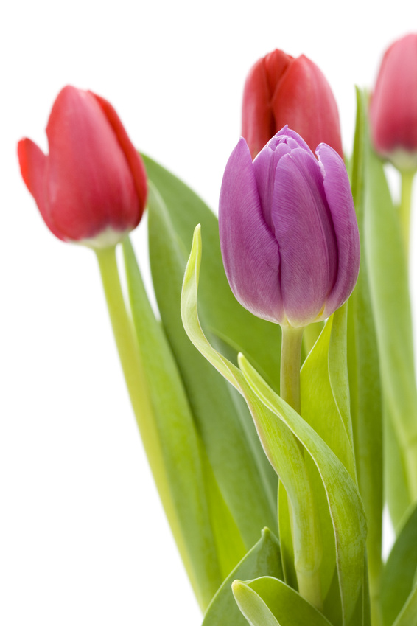

Figure 5.1: Tulips prior to irradiation by kryptonite. Photograph: author

Number the figures according to the main chapter in which they appear. Subchapters are not considered. This means that the figures in the introduction (typically Chapter 1) will be: Figure 1.1, Figure 1.2 etc. In the second chapter, Figure 2.1, Figure 2.2, Figure 2.3, etc.

The description of the table, unlike the figure, is usually above the table. See Table 5.1. There is no need to copy the entire contents of the table header, which immediately follows. Individual variables in the table are sorted into columns. In the table, independent variables, proband categories, etc. are on the left, dependent variables on the right. Put units in parentheses at the heading of the table, not separately for each number. Explanatory notes (e.g. achieved significance level, whether data are reported as mean + standard error of the mean, what statistical test was used, etc.) are placed below the table and referred to as superscript (symbols, numbers, letters) at the relevant place of the table. Each figure and table should be provided reference from the main text.

Table 5.1: Reaction time *T*20 of the signal of peripheral oxygen saturation, *Sp*O2, measured by three different devices

|  |  |  |  |
| --- | --- | --- | --- |
|  | *T*20 (s) | | |
| Phase | Root Radical-7 | Nellcor N-600 | Carescape B650 |
| Hypoxic | 52±15* | 65±19* | 56±15 |
| Hyperoxicc | 43±14 | 55±28 | 49±15 |
| Hypercapnic | 75±23 | 119±47# | 73±41# |

Data were measured on the similar group of 14 probands and are listed as an arithmetic mean ± standard deviation. Symbols * and # mean statistical significant difference (*p*<0,05) of times for the similar phase.

# Discussion

In this section summarize the obtained results *(main findings of the work)* and subsequently interpret these results with respect to the aims. It is also possible to confront the obtained results and outputs with the results and outputs of other authors, products of other companies etc. It is necessary to cite the sources correctly (citations of the works that are compared and discussed here). The limitations of the work are also discussed. Finally, the future direction of thesis can be outlined. Speculate on the clinical importance of thesis with caution.

The structure and content of this part have been discussed in courses “Methodology of Research and Information Sources” and “Diploma seminar”.

# Conclusion

The conclusion briefly summarizes the fulfilment of the set aims of the thesis. The structure and content of this part have been discussed in courses “Methodology of Research and Information Sources” and “Diploma seminar”.

Summary of fulfilled (or perhaps to a lesser degree not fulfilled) aims of the thesis follows the introduction of the thesis. From the other parts of the thesis (methods, results and discussion), only the most important and to the minimum necessary extent is taken over - the conclusion of the work should not be a repetition of the abstract, results or discussion. The end of the conclusion may contain substantiated speculations on the importance of the thesis for the future or significant recommendations for further research or practice if they directly follow from the results of the thesis.

# References

A uniform style of citations is necessary throughout the document. If references to bibliographic citations are in the form of numbers, e.g. [1], then the numbers are assigned to each of the cited documents in the order in which they are first referred to in the text of the thesis, citations of sources in the References are ranked in the same manner.

Bibliographic citations are recommended to be formatted according to ISO 690. Other internationally recognized citation formats may be chosen.

For managing and formatting of citations, we recommend the Citations PRO service, which the CTU subscribes to. The service is available at:

[www.citace.com/citace-pro](http://www.citace.com/citace-pro)

It is also advisable to use the Mendeley or Zotero platform, available at: <https://www.mendeley.com/guides/citation-guides/> and <https://www.zotero.org>

1. GUYTON, Arthur C. a John E. HALL. *Textbook of medical physiology*. 11th ed. Philadelphia: Elsevier Saunders, 2006. ISBN 07-216-0240-1.

# Attachment A: Formatting requirements

* Use the serif font (Times New Roman, Georgia, Garamond, etc.), size 12 for the main text of the thesis. Typeset descriptions of figures and tables in the same font or a font that is as similar as possible. Typeset descriptions of figures and tables in the similar font but smaller size. Headings, page numbers, possible headers or footers, etc. can be typeset either in the same font as the main text or in sans serif font (e.g. Calibri). **Do not use more than two different fonts in the thesis.**
* Spacing, paragraph indentation, font size in headings, etc. are defined by the individual styles used in this template.
* The edges of the pages are always 2.5 cm on each side.
* The thesis is printed double-sided on A4 format paper and bound with comb binding.
* Pages are numbered in Arabic numerals starting with the first (front) page. The pages are numbered from the first (front) page, which means that there are no page numbers on the front page, assignment, declaration, acknowledgment and abstracts.
* The main chapters of the thesis, starting with introduction and ending with conclusion, are numbered in Arabic numerals. The list of references does not have a number. Mark attachments in capital letters of the English alphabet.
* Start each main chapter of the thesis (level 1 heading) on a separate page.

# Attachment B: Basic typographic rules

* Typeset physical and physiological quantities and mathematical variables in italics. Typeset abbreviations and symbols that do not represent a numerical value in normal script - just like the physical units.
* Units of quantities and symbols (such as percentage) are separated from the numerical data by a non-breaking space. If you write without a space, it has the meaning of and adjective / attribute / modifier e.g. “10 Ω” reads “ten ohms” and “10Ω” reads “ of ten ohm”.
* A non-breaking space must be marked in the text editor. E.g. in Microsoft Word, the combination <Shift> + <Ctrl> + <spacebar> is used.
* Non-syllabic prepositions and conjunctions (does not concern “and”) must not remain at the end of the line. Therefore, use a non-breaking space after them.
* Distinguish between a hyphen and a dash. Hyphen is a short line used to join two words (e.g. Czech-English dictionary). A dash is used to indicate a pause in the text, and then we usually type it with spaces, or to indicate the range (5–10) when it is written without spaces.

# Attachment C: Further recommendations for the sake of clarity of the text

* Typeset figures and tables separately in the text, without wrapping the text on the sides. Do not insert figures and tables to the page before the paragraph ends. Make sure the figure or table description remains on the same page as the figure or table itself.
* First line of a paragraph should not be left alone at the end of the line and the last line of a paragraph should not be left alone at the beginning of a new page.
* All abbreviations, except for the well-known such as DNA, should be explained in the thesis at their first occurrence in the main text and also in the abstract if it is necessary to use them there.
* Refer to the equations by their number, after their inclusion in the text.
* All figures and tables must be referred to from the main text using their number